Query:

1.Most Popular Tracks in Playlists:

SELECT track_name, `artist_s__name`, in_spotify_playlists

FROM kaminiyelamar.Spotify23.Spotify_23

ORDER BY in_spotify_playlists DESC

LIMIT 10;

2.Trends in Music Over Years:

SELECT released_year, AVG(danceability__) as Avg_danceability , AVG(energy__) as Avg_energy, AVG(acousticness__) as Avg_acousticness

FROM kaminiyelamar.Spotify23.Spotify_23

GROUP BY released_year

ORDER BY released_year;

3.Popular Music Features:

SELECT key, mode, AVG(danceability__) as avg_danceability, AVG(valence__) as avg_valence

FROM kaminiyelamar.Spotify23.Spotify_23

GROUP BY key, mode

ORDER BY avg_danceability DESC, avg_valence DESC;

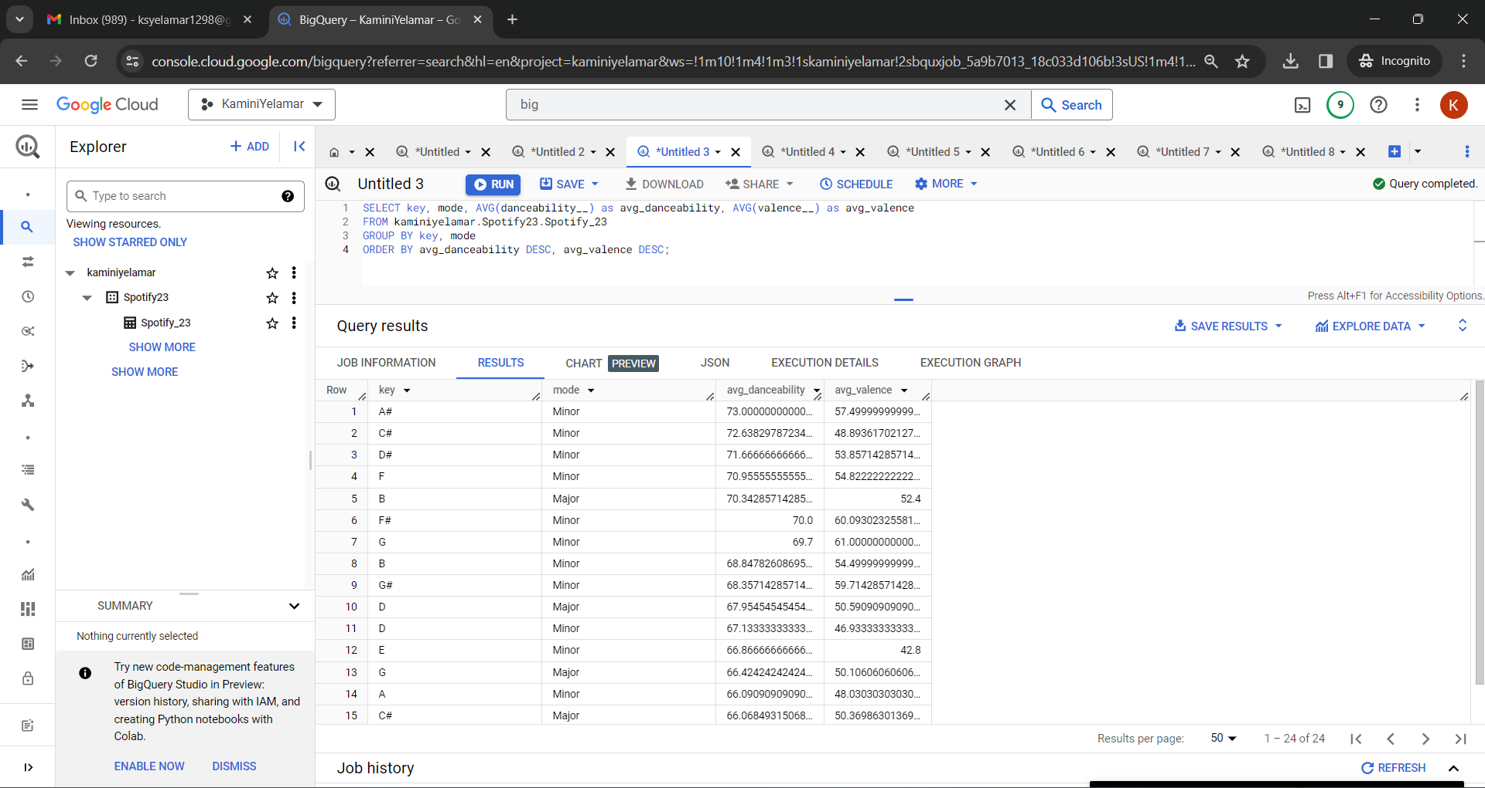

4.Comparison of Playlist vs Chart Presence:

SELECT track_name, `artist_s__name`, in_spotify_playlists, in_spotify_charts

FROM kaminiyelamar.Spotify23.Spotify_23

WHERE in_spotify_playlists > 1000 OR in_spotify_charts > 50

ORDER BY in_spotify_playlists DESC, in_spotify_charts DESC;

5.Comparing Song Popularity Across Different Music Streaming Platforms:

SELECT track_name, `artist_s__name`, streams, in_spotify_playlists, in_apple_playlists

FROM kaminiyelamar.Spotify23.Spotify_23

ORDER BY streams DESC;

6.Relationships Between Song Attributes and Music Popularity Over Time:

SELECT released_year, AVG(danceability__) AS avg_danceability, AVG(energy__) AS avg_energy, AVG(acousticness__) AS avg_acousticness, AVG(streams) AS avg_streams

FROM kaminiyelamar.Spotify23.Spotify_23

GROUP BY released_year

ORDER BY released_year;

7.Improving Attributes for Least Streamed Songs:

WITH LeastStreamed AS (

  SELECT track_name, `artist_s__name`, streams

  FROM kaminiyelamar.Spotify23.Spotify_23

  ORDER BY streams

  LIMIT 100

)

SELECT AVG(danceability__) as Avg_danceability , AVG(energy__) as Avg_energy, AVG(acousticness__) as Avg_acousticness, AVG(valence__) as Avg_valence, AVG(speechiness__) as speechiness

FROM kaminiyelamar.Spotify23.Spotify_23

WHERE track_name NOT IN (SELECT track_name FROM LeastStreamed);

8.Top Artists by Stream Count:

SELECT `artist_s__name`, SUM(streams) as total_streams

FROM kaminiyelamar.Spotify23.Spotify_23

GROUP BY `artist_s__name`

ORDER BY total_streams DESC

LIMIT 10;

Visualization: